Optmizing a dynamic talking neural net using genetic algorithm

Sinha Anul Kumar

MS Columbia University

Abstract

Neural networks are currently being used to solve almost all the problems involving large data set. However, the field of generative chat bots are still in nascent stages. This paper discusses one method to optimize the structure of a neural network to make it learn from the raw audio signal. It also discusses the results found, problems faced and future direction.

Index Terms— Introduction, system designs, experiment details, results and discussions, conclusion and future works, references

1. Introduction

Neural networks are constantly evolving and replacing traditional methods of problem solving. The speech generation part is still in the research stages. While it is easier to store speech data in a database and retrieve replies from that database, it is very hard to generate the reply without any database purely by neural network.
There are several problems faced when trying to solve it. If the input is in the form of raw signal, it increases the total number of samples to be processed by thousand-fold. If the input is in the form of a spectrogram, it increases the input dimension thus making the network very complex. Not to mention the memory requirements associated with it.
One other method is used to solve such daunting problem. It is Genetic Algorithm. Genetic Algorithm is inspired by nature’s evolutionary system. It creates a population of systems at each stage, selects the top scorers and breeds them to generate the population for next stage. This way several models are checked at a time. So, it can converge to a good model.
Combining both neural net and genetic algorithm will provide good results, however there is a catch. Since genetic algorithm is checking multiple models in each generation, the cost and time taken by the genetic algorithm increases multifold.

2. SYSTEM DESIGNS

The system was inspired by biological brain. It was divided into two parts, the primal emotion part and the response part. Each system has neurons which have
- Actual value in neuron
- Active threshold
- Silent threshold
- LTPLTD
- Excite Probability
- Inhibit Probability
- Fired/not fired flag
- Previous value if not fired

The connections in each of the systems are both forward and backward. The probability of connection is higher near initial layers and decreases thereafter. So, the initial layers contain high density of connections. The zero connections are replaced by 0.001 to make sure that the connections never become zero. This way there always be some gradient and those neural connections will not be saturated by zero.
They also have an epsilon value for random exploration. This is to make them more robust.
If the neurons value is less than threshold it does not fire and that value is stored in the previous value and it decays by a constant rate to simulate the diffusion of ions. The mutation rate is used by genetic algorithm to mutate the population. Mutation is done to explore more models and also to make it more stable.
The input [1] is rescaled to be in between -1 and 1 and then inside the network they are shifted up by 1 so they lie between 0 and 1. This is to remove any negative values as the negative values are being used for inhibition system. The output is also scaled between 0 and 2 using shifted tanh.

Each of the systems were controlled by a control system which used weights to optimize weight update. It considered learning rate, epsilon, max weight, emotion neuron output and input to each weight of emotion and response system. These were then combined non-linearly to give the rate by which each neural weight should be increased or decreased.
The entire design is at: https://github.com/anulksinha/speech

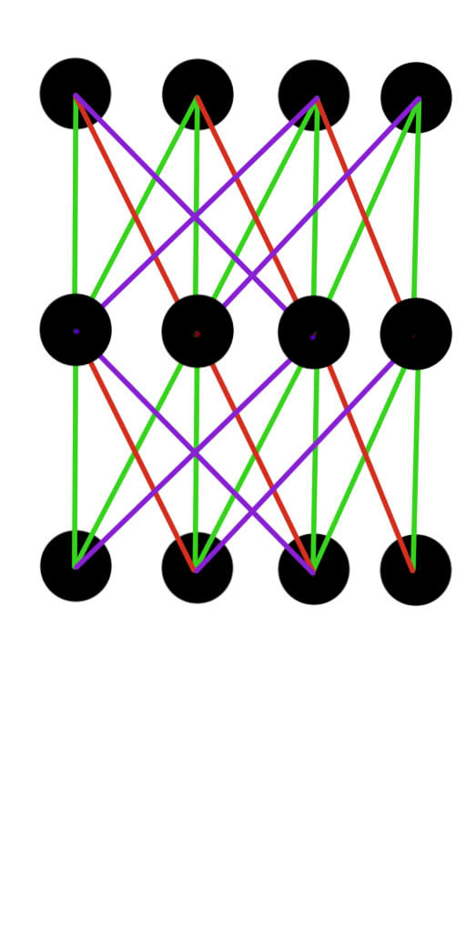
Figure 1: Neural Connection
The green lines are forward structural connections same for all network with different values. The red lines similarly are structural backward connections. The purple lines are the random connections (forward or backward) different for each network.

3. EXPERIMENT DETAILS

Several experiments were conducted to see how the network is behaving.
The first experiment involved optimizing the network by MSE (mean square error). The network easily learned it in no time.
The second experiment involved optimizing using the cross correlation of actual output and the predicted output. The genetic algorithm was able to optimize however took longer time.
Each of these experiments was combined with a weight update control system. The number of input dimensions, number of neurons, layers, epsilon, learning rate were also played with.

4. RESULTS AND DISCUSSIONS

We immediately ran into ‘nan’ error as the weights were becoming too low or too high. To fix this a minimum of 0.001 was added to each weight and the weights were standardized using the max weight value. The weights were also rounded to 3 decimal places to prevent ultra-high precision.
During initial phase of experiments at each generation of genetic algorithm a different input set was being presented. As a result, it took a longer time to optimize the design. Also, the neural weights and control system weights were optimized separately. First the neural weights were optimized, then the control system weights were optimized.
As we can see from the graphs, by combining them together it resulted in a better mse.
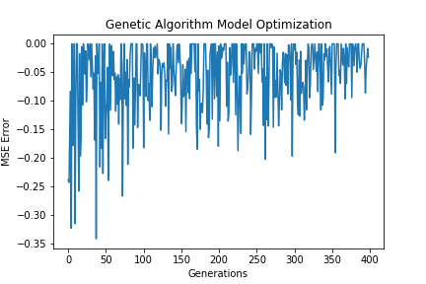
Figure 2: Neural weights being optimized by Genetic Algorithm
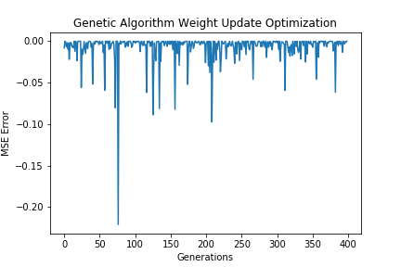
Figure 3: Control weights being optimized by Genetic Algorithm
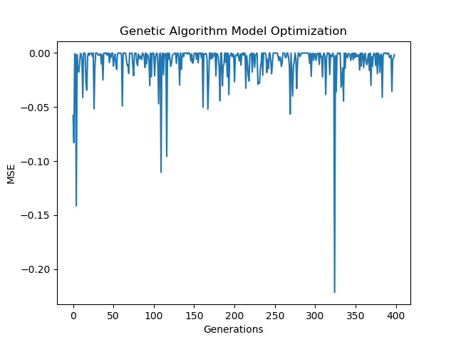
Figure 4: Both neural and control weights being optimized simultaneously by Genetic Algorithm
The same thing was done for cross correlation coefficient optimization; however, it did not give good results. So, the approach was changed. Instead genetic algorithm was running for each input set first and once it reached a certain threshold, the best model was selected and used for the optimization of the second input set.
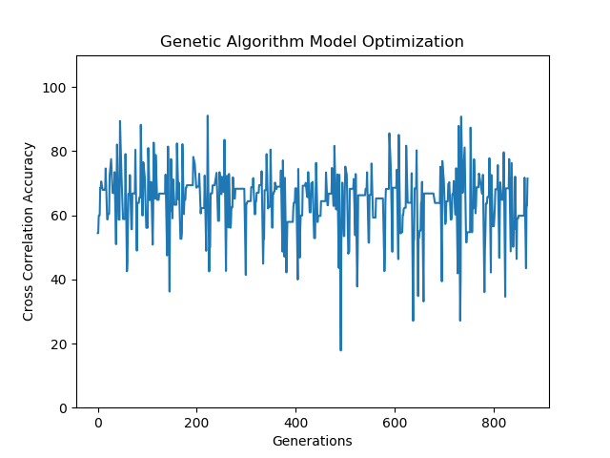
Figure 5: Model optimized for each input set and moving to next set
So, as we can see the model optimizes for each input set within a given threshold of cross correlation and max generation (here 20) and then moves to next input set and repeats. However, the test results were still not good.
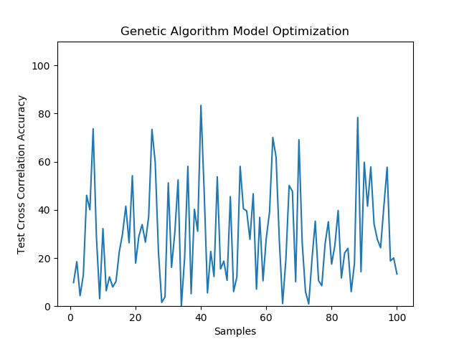
Figure 6: Test result cross correlation
The same thing was observed when the control system was active and inactive. During inactive phase the control system doesn’t update weights, so they are fixed. During active phase the weights get updated after each processing of input.

Now to check how the mse performed in similar condition, we trained model for each input set optimizing for mse and repeating the above cases.
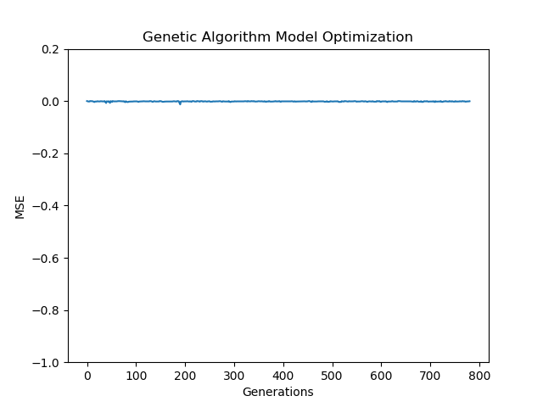
Figure 7: MSE during training (model optimization)
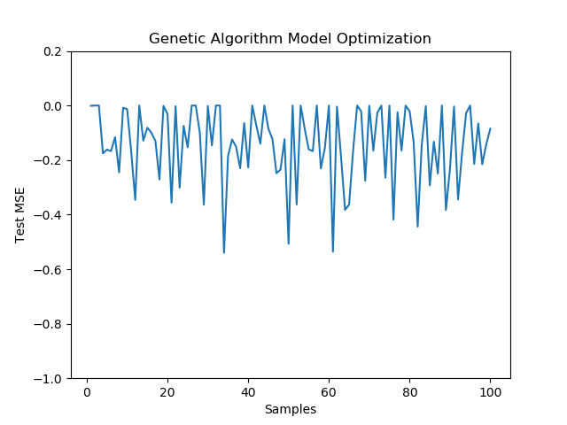
Figure 8: MSE during testing
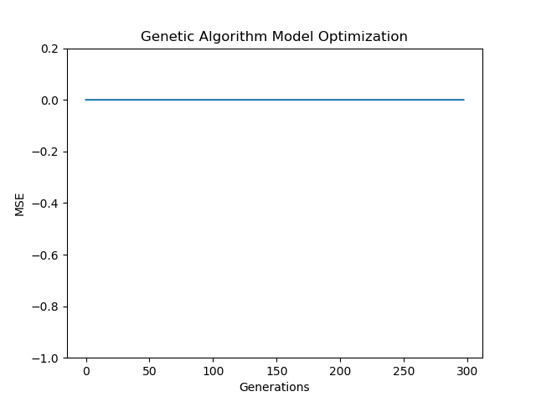
Figure 9: MSE during training with active weight update
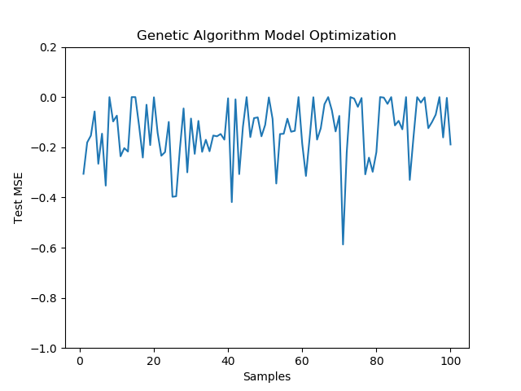
Figure 10: MSE during testing with active weight update

5. CONCLUSION AND FUTURE WORKS

As we can see from the results training the model using MSE is much easier and faster and the model seems more stable with the weight update as compared to cross-correlation. So, a compromise has to be made. To choose between MSE or cross-correlation. Cross correlation will result in closer shape of the output to the input but is difficult to train and requires too many examples to give a better output. MSE is easier to train, gives lower error but need not preserve the shape.
So, the future work involves preserving both by giving equal weightage to both cross-correlation and mse. It also involves some changes in the design to improve speed and accuracy. Also, it involves dealing with spectrogram data to reduce the number of samples.
The code is present at: https://github.com/anulksinha/speech
The data was taken from: https://www.gutenberg.org/browse/categories/1 [1]

12. References

[1] Project Gutenberg. (n.d.). Retrieved November 21, 2017,from https://www.gutenberg.org/browse/categories/1

